Ethical Hacking Summer Training Lab Exam
Lab 6: SCANNING NETWORKS
Name: Mowa Dacgne Danielle
Roll Number: 2402019024
Branch: B.Sc. Cybersecurity, 4th semester

Definition:
It is the process of identifying active devices, open ports, and running services on a network to assess its security posture and inventory.
It involves sending probes, such as ping requests or TCP packets, to a range of IP addresses and analysing the responses to determine which hosts are live and accessible.

Lab 6: Scanning Networks Discover live hosts, open ports, services, and OS details of the Windows target machine.

The following steps describes network scanning done on using Kali Linux and Windows iso:

Step 1: Finding the Windows IP address
On the Windows VM, open Command Prompt and run “ipconfig”

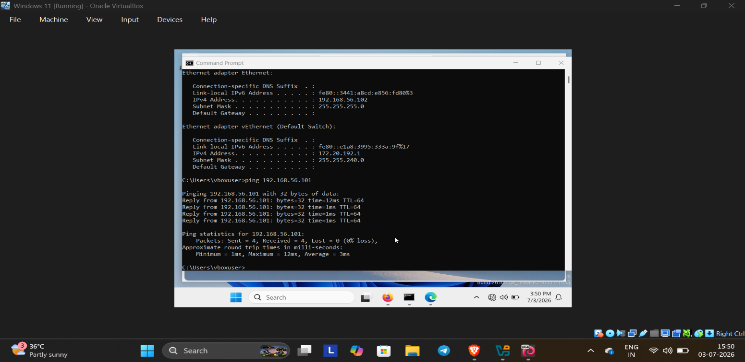

Step 2: Verify connectivity that is checking if the host is reachable
On Kali enter “ping Windows IP”

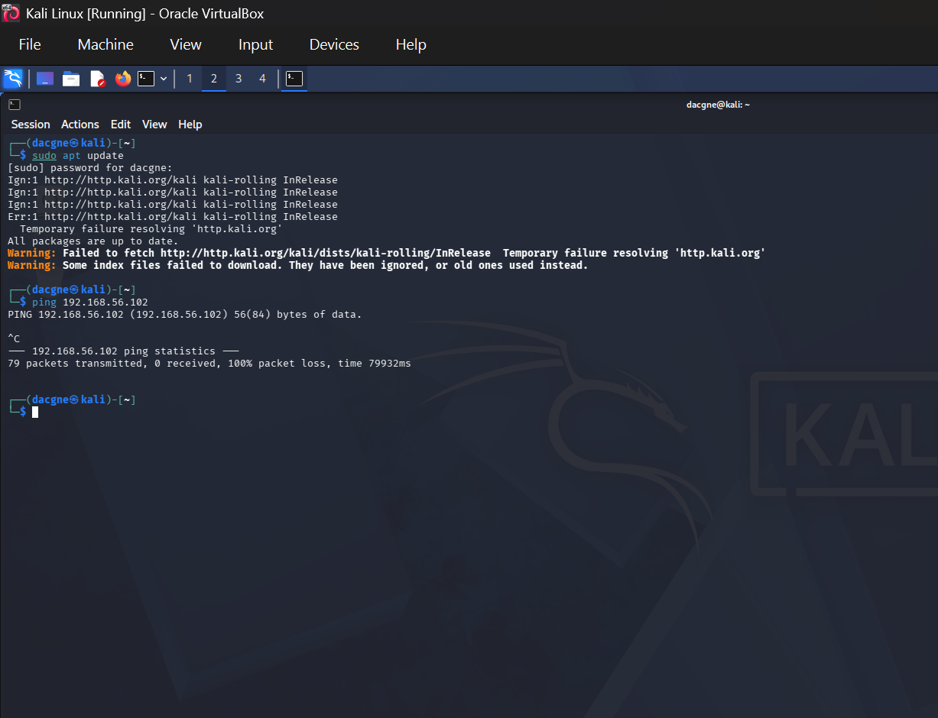
- Output obtained shows that the host was successfully reachable

Step 3: identifying the live host run “nmap -sn 192.168.56.0/24”
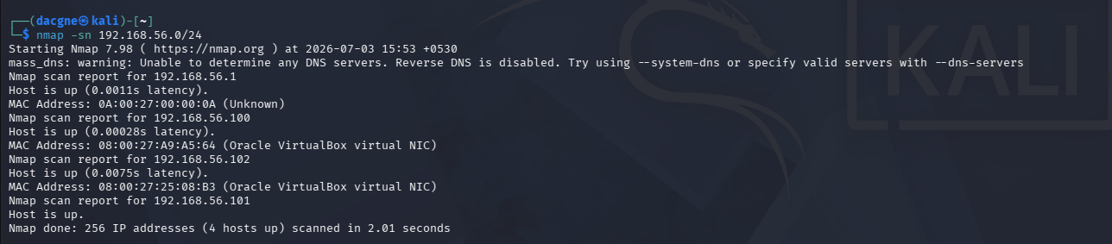
- Result: The scan identified four live hosts on the network. This confirms that the target systems are reachable before performing further scans such as port scanning, service detection, or operating system detection.

Step 4: Scan for open ports using the nmap tool(run nmap Windows IP)
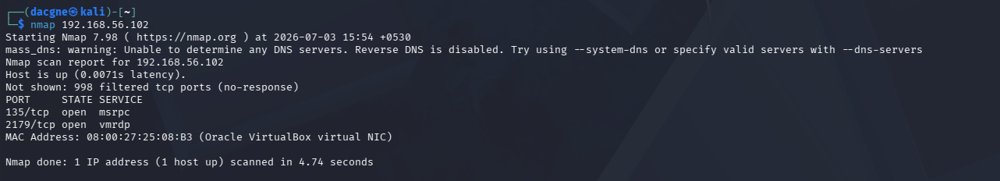

- Result: The Nmap scan successfully identified the Windows target as an active host. Two open TCP ports were discovered:
- 135/TCP (MSRPC): Used by Microsoft Windows for Remote Procedure Call services.
- 2179/TCP (VMRDP): Used for Virtual Machine Remote Display Protocol in virtualized environments.
- The remaining 998 scanned ports were filtered, indicating that they were protected by a firewall or another network filtering mechanism.

Step 5: Detect Services (run nmap -sV Windows IP)

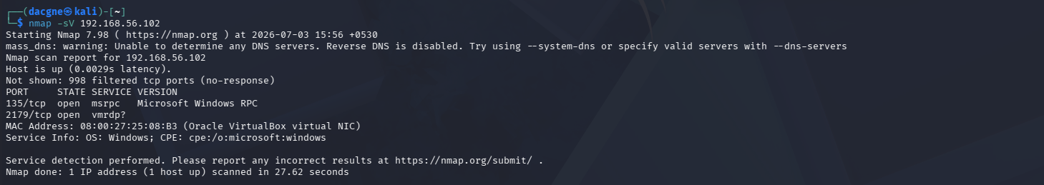

Step 6: Get OS details of the Windows target machine(run sudo nmap -O Windows IP)

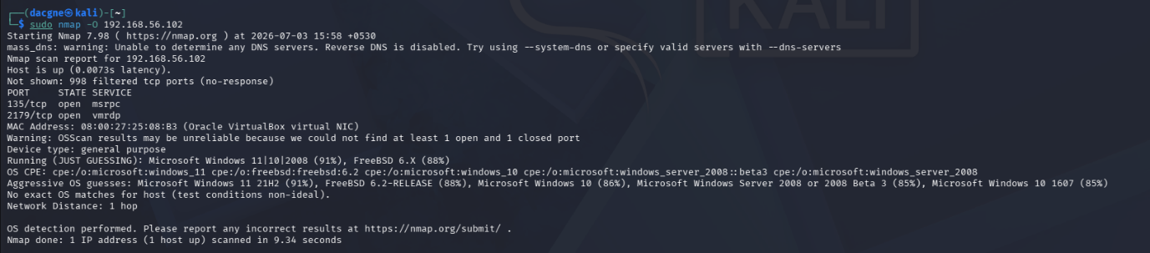

- The OS of the target system is Microsoft Windows 11|10|2008

Conclusion
The Nmap scan successfully identified the active Windows host, discovered its open ports and running services, and demonstrated the importance of reconnaissance in cybersecurity.
The results showed that the target was reachable and that only a limited number of services were exposed, indicating that firewall protection was in place. This practical exercise improved understanding of host discovery, port scanning, and service enumeration using Nmap.

